Name of Plenary Speaker | Prof. Azirah Hashim
Photo | 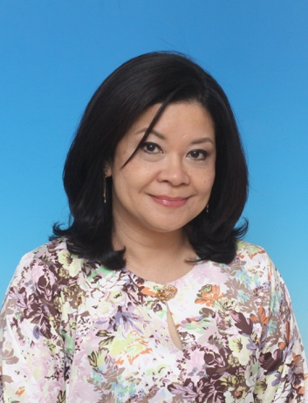
Brief description beneath the photo  University & Country | University of Malaya, Malaysia
Bio | Azirah Hashim is Professor at the Faculty of Languages and Linguistics, University of Malaya, Malaysia. She has been Executive Director of the Asia-Europe Institute; Director of the Centre for ASEAN Regionalism; Dean of the Faculty of Languages and Linguistics and Dean of the Humanities Research Cluster at the university. Her research interests include Language Contact in Southeast Asia, Language and Law and Higher Education in ASEAN. Recent publications include English in Southeast Asia and ASEAN: Transformation of Language Habitats, Routledge, 2021 (co-authored with Gerhard Leitner) and Asia and Europe in the 21st Century: New Anxieties, New Opportunities, Routledge, 2021 (co-edited with Rahul Mishra and Anthony Milner). She is on the Editorial and Advisory Board of several journals such as English Today, World Englishes and Asian Journal of Applied Linguistics. She has also led many projects such as the multi-national Erasmus+ Capacity Building in Higher Education project ‘Building Research Capacity in Higher Education Institutions in Malaysia and Laos’ and the Jean Monnet Centre of Excellence ‘ASEAN and EU in Dialogue’ at the Asia-Europe Institute. She is currently President of the International Association of Applied Linguistics (AILA) and Humboldt Ambassador Scientist of the Alexander von Humboldt Foundation, Germany. She also sits on the executive committee of the Asia Pacific LSP and Professional Communication Association and serves as Higher Education expert in the EU Support to Higher Education in the ASEAN Region programme.

Name of Plenary Speaker | Martin Dewey
Photo | 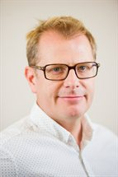
Brief description beneath the photo  University & Country | Reader in Applied Linguistics at King’s College London
Bio | Martin Dewey is Reader in Applied Linguistics at King’s College London. His research focuses on the globalization of English, and the role of English as a Lingua Franca (ELF). His research primarily entails exploring the relevance of ELF in language teacher education and the impact this has on how we conceptualize language and language knowledge in English language teaching. His research interests also include a focus on multilingualism, language attitudes/ideologies and and critical pedagogy. He has presented and published widely on his research work. He is co-author, together with Alessia Cogo, of Analyzing English as a Lingua Franca: A Corpus Driven Investigation (Continuum 2012) and co-editor, together with Jennifer Jenkins and Will Baker, of Routledge Handbook of English as a Lingua Franca (Routledge 2018). He is editor in chief of Journal of English as a Lingua Franca.

Name of Plenary Speaker | Dr. Willy A Renandya
Photo | 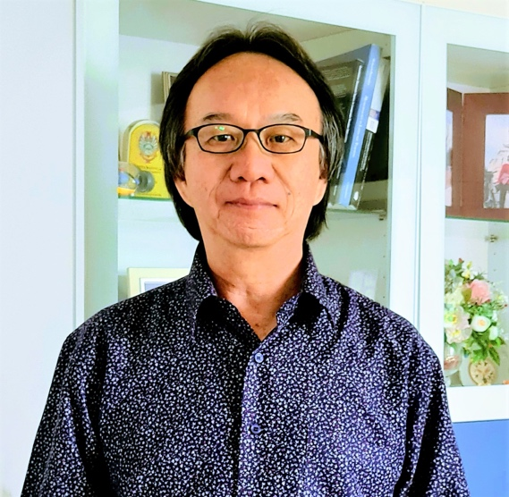
Brief description beneath the photo  University & Country | Nanyang Technological University, Singapore
Bio | Dr Willy A Renandya is a language teacher educator with extensive teaching experience in Asia. He currently teaches applied linguistics courses at the National Institute of Education, Nanyang Technological University, Singapore. He has given more than 100 plenary presentations at international ELT conferences and published extensively in the area of second language education. His publications include Language Teaching Methodology: An anthology of current practice (2002, Cambridge University Press), Student-centred cooperative learning (2019, Springer International), and a recently published book chapter Growing Our Research Impact (2020, Springer International). He maintains a large language teacher professional development forum called Teacher Voices:

